|  |  |
| --- | --- |
|  | **MINISTRY OF**  **EDUCATION AND TRAINING** |

**CAPSTONE PROJECT REPORT**

**Report 1 – Project Introduction**

- Hanoi, December 2022 -

Table of Contents

Acronyms and Definitions 1

Record of changes 1

Report I. Project Introduction 2

1. Overview 2

1.1. Project Introduction 2

1.2. Project Team 2

1.2.1. Supervisor 2

1.2.2. Team Members 2

2. Product Background 3

3. Existing Systems 11

3.1. Eatthismuch 11

3.2. Fatsecrets 12

3.3. MyFitnessPaypal 13

4. Business Opportunity 14

5. Software Product Vision 16

6. Project Scope & Limitations 16

6.1 Major Features 16

6.2. Limitation & Exclusion 17

# Acronyms and Definitions

|  |  |  |
| --- | --- | --- |
| **#** | **Acronym** | **Definition** |
| 1 | 4HTN | 4HealthyNutrium Website System |
| 2 | NADAFI | Nutrition and dietary advice for individuals |
| 3 | FE | Feature |
| 4 | LI | Limitation |
| 5 | EX | Exclusion |

Acronyms and Definitions Table

# Record of changes

|  |  |  |  |
| --- | --- | --- | --- |
| **Date** | **Status** | **In charge** | **Change description** |
| 31/10/22 | M | All teams | Complete report number 1 and 2.  Iteration 1 is in progress.  Initiate unit test for iteration 1.  Modify some requirement changes. |
|  |  |  |  |
|  |  |  |  |

A – Added, M – Modified, D – deleted

# Report I. Project Introduction

## 1. Overview

### 1.1. Project Introduction

* Project name: 4HealthyNutrium Website System
* Project code: 4HTN
* Group name: SWP493 – G5
* Software type: Web.

### 1.2. Project Team

#### 1.2.1. Supervisor

|  |  |  |  |
| --- | --- | --- | --- |
| **Full Name** | **Email** | **Phone Number** | **Title** |
| Bùi Ngọc Anh | [anhbn5@fe.edu.vn](mailto:anhbn5@fe.edu.vn) | 091 534 3020 | Supervisor |

Table 1.2.1. Supervisor’s Information

#### 1.2.2. Team Members

|  |  |  |  |
| --- | --- | --- | --- |
| **Full Name** | **Email** | **Mobile** | **Role** |
| Nguyễn Hoàng Việt | vietnhhe140789[@fpt.edu.vn](mailto:duchmhe140725@fpt.edu.vn) | 098 529 5760 | Leader |
| Nguyễn Viết Long | longnvhe140051[@fpt.edu.vn](mailto:anhlthe140428@fpt.edu.vn) | 096 337 2727 | Member |
| Nguyễn Đức Sơn | sonndhe140443[@fpt.edu.vn](mailto:datndhe140411@fpt.edu.vn) | 096 905 1715 | Member |
| Lê Mạnh Cường | cuonglmhe130386[@fpt.edu.vn](mailto:anhtdhe140447@fpt.edu.vn) | 096 374 3383 | Member |

Table 1.2.2. Team member’s information

## 2. Product Background

In recent years, along with strong socio-economic development, people's health care needs are increasing day by day. Therefore, how to take care of your own health is a big question in everyone's mind. We conducted a survey with 50 people of various professions, gender and ages for 1 week (September 17th - 24th, 2022).

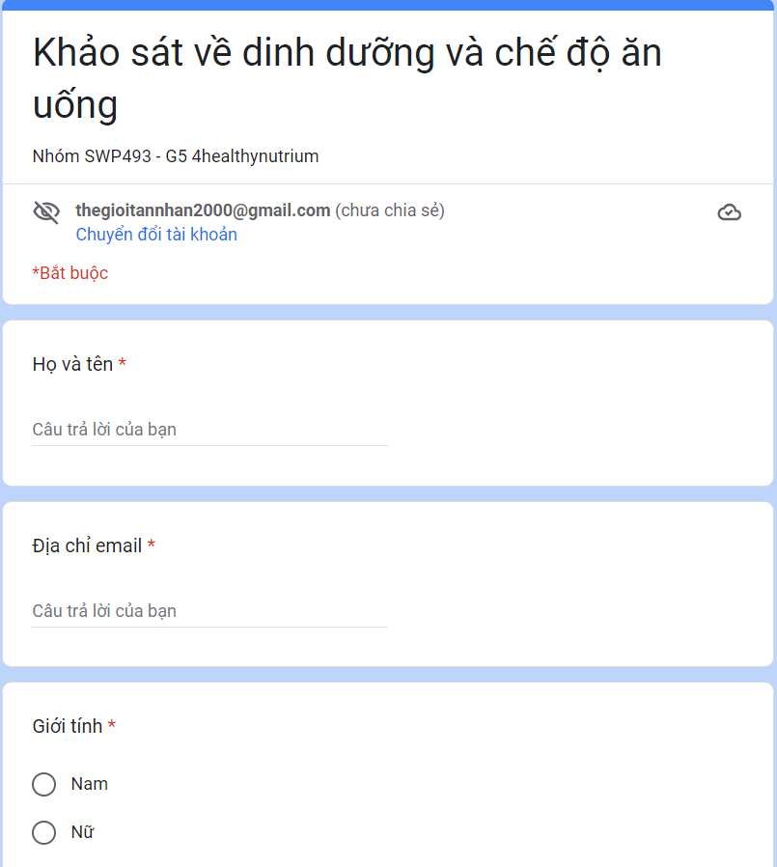

*Figure 2:1. Our survey form*

With 74 different responses from 74 people of different professions, gender and ages, we gathered a lot of information about each person's nutritional needs and habits:

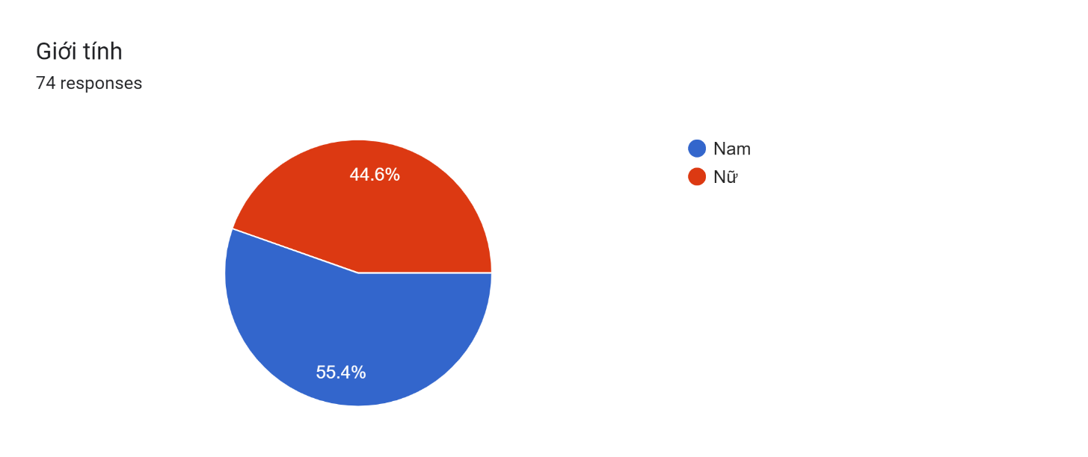  
*Figure 2:2. Statistics of survey participant's gender*

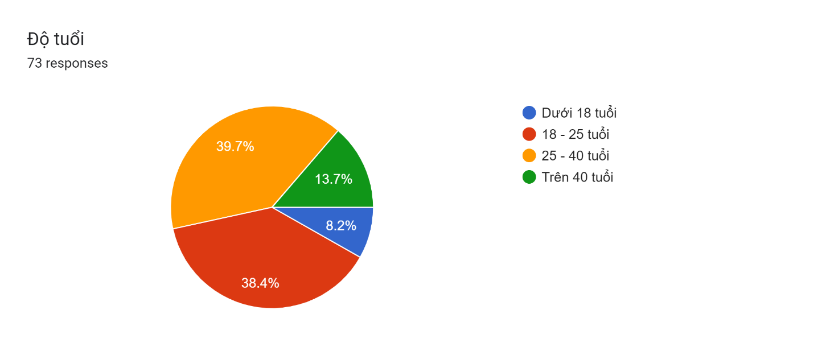

*Figure 2:3. Statistics of survey participant's age*

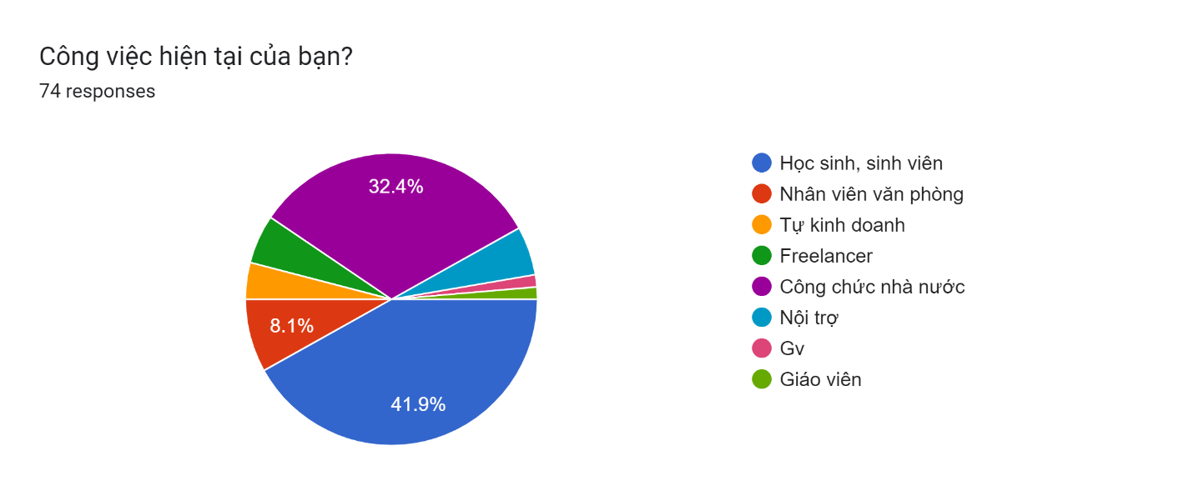

*Figure 2:4. Statistics of survey participant's profession*

First, we can see that most of the survey participants are extremely health conscious and are willing to invest money and effort for their health needs.

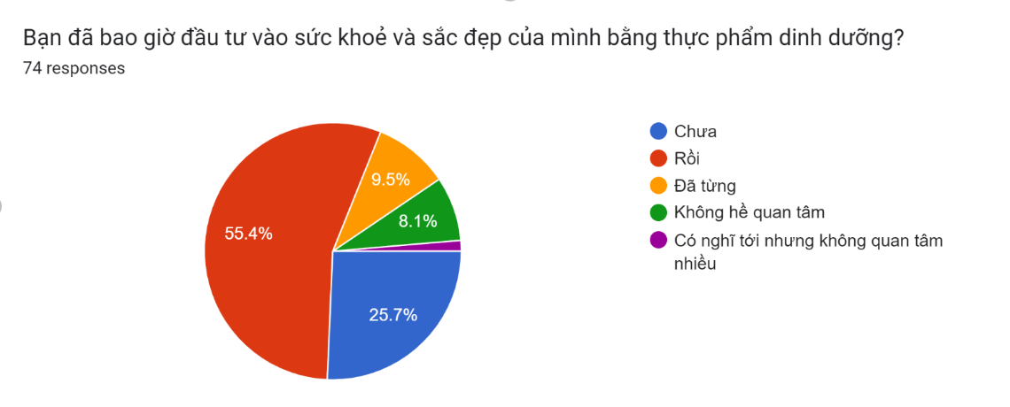

*Figure 2:5. Statistics of survey participant's the need to invest money and effort in health and beauty with nutritious food*

Forms response chart. Question title: Bạn quan tâm đến chăm sóc sức khoẻ của mình ở mức nào?
. Number of responses: 74 responses.

*Figure 2:6. Statistics of survey participant's level of concern for health*

Next, we conducted a survey on the difficulties that the interviewees encountered when learning about and building a healthy diet and exercise regimen. It can be seen that quite a few interviewees attributed the lack of nutrition knowledge to the lack of knowledge. Besides, the lack of a clear and specific plan also makes it difficult for many people to build a diet and exercise regimen.

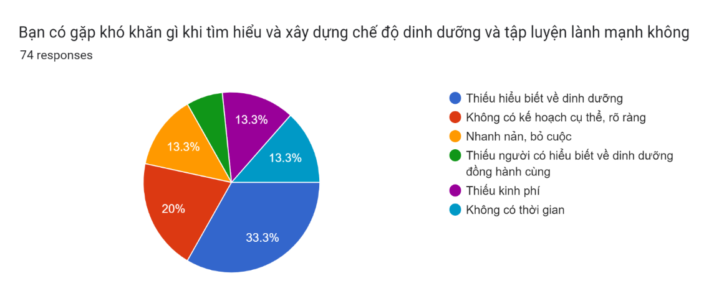

*Figure 2:6. Statistics of survey participant's level of concern for health*

That's why our team decided to work together to build a website for nutrition and exercise advice to help satisfy everyone's needs.

In order to be able to create a website to help advise on diet, we have prepared the basic nutritional knowledge required, aimed at Vietnamese people who need to maintain and improve health. Our website will help users calculate the energy they need for the whole day based on the information provided by the user. From there, suggesting to user suitable menus to help them maintain and improve their personal health.

First, we learn about the basis for building energy recommendations for Vietnamese people. Based on the formula[[1]](https://drive.google.com/drive/folders/1EsUWzp1ufCXleiTTQSDOBzx7jxfK1--3):

**A = B x C**

A: Recommended all-day energy needs (kcal).

B: Basal metabolic energy for the day (kcal).

C: Physical activity coefficient (PAL).

From the above basis, we learned about the basic metabolic energy in a day and the physical activity coefficient of Vietnamese people.

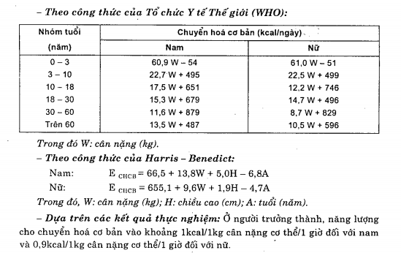

*Figure 2:7.1. Statistics of basic metabolic energy of Vietnamese people* [[2]](https://drive.google.com/file/d/1WTg9GA-RXxcPPfJ1JojHX7fDRRZTa0GW/view?fbclid=IwAR0My0Ap6B-ZtjAJSDE5IYdCPgQ1eVPtqrp1oVNPHtRG03wNHaXeX7Bxu3g)

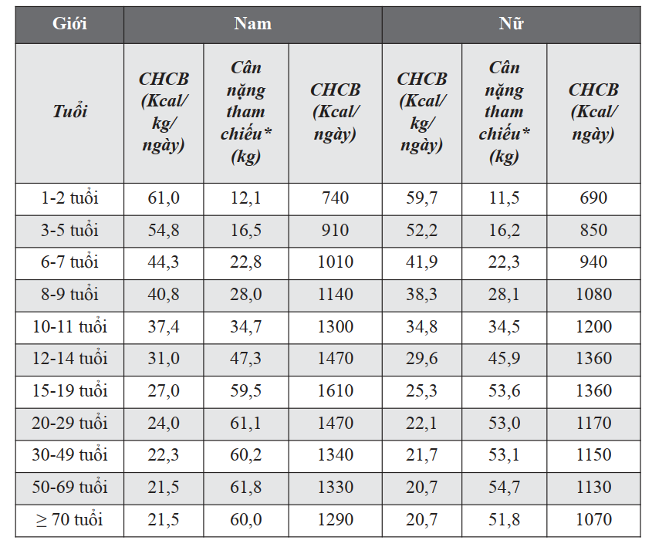

*Figure 2:7.2. Statistics of basic metabolic energy of Vietnamese people* [[1]](https://drive.google.com/drive/folders/1EsUWzp1ufCXleiTTQSDOBzx7jxfK1--3)

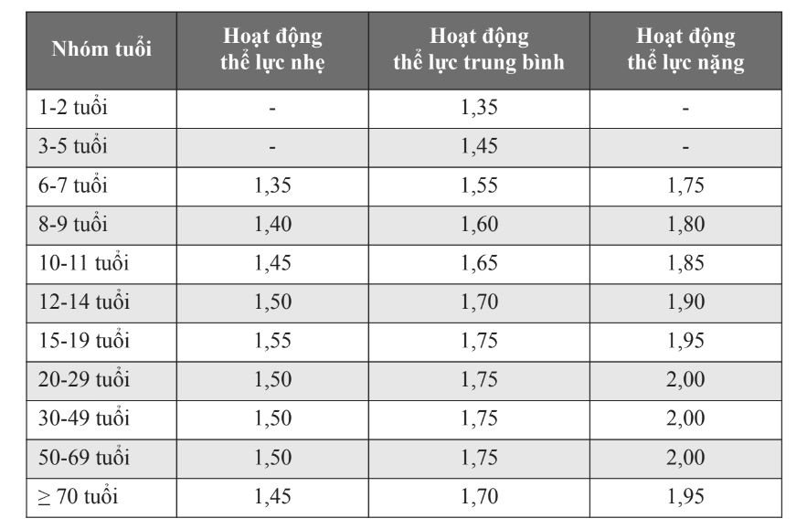

*Figure 2:8. Statistics of the physical activity coefficient* *of Vietnamese people* [[1]](https://drive.google.com/drive/folders/1EsUWzp1ufCXleiTTQSDOBzx7jxfK1--3)

We also learned more about the classification of physical activity levels by type of work so that it is easier to categorize the physical activity coefficients by different occupations.

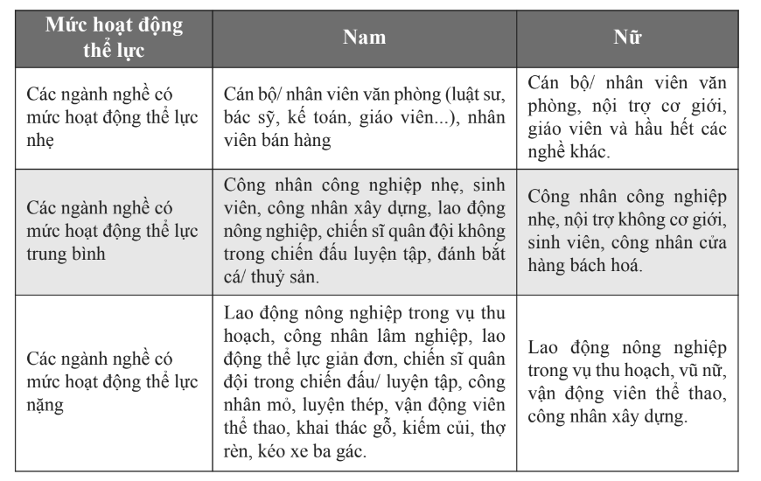

*Figure 2:9 Statistics of classification of physical activity levels by type of work of Vietnamese people* [[1]](https://drive.google.com/drive/folders/1EsUWzp1ufCXleiTTQSDOBzx7jxfK1--3)

From the above parameters, we have continued to collect data on recommended energy needs for Vietnamese people.

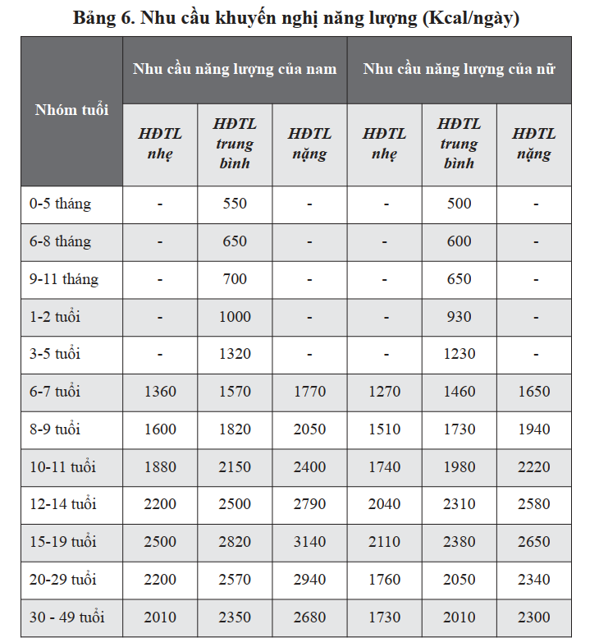

*Figure 2:10 Statistics of recommended energy needs* *of Vietnamese people* [[1]](https://drive.google.com/drive/folders/1EsUWzp1ufCXleiTTQSDOBzx7jxfK1--3)

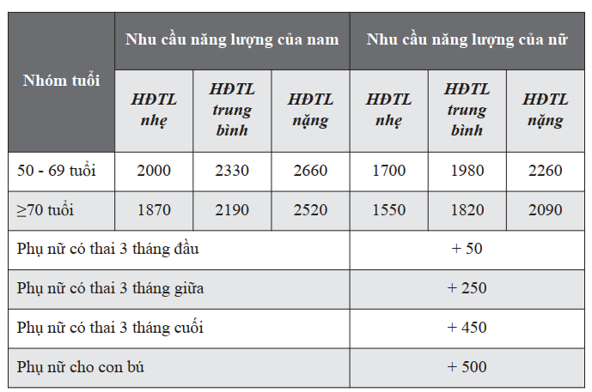

*Figure 2:11 Statistics of recommended energy needs* *of Vietnamese people* [[1]](https://drive.google.com/drive/folders/1EsUWzp1ufCXleiTTQSDOBzx7jxfK1--3)

In addition to ensuring energy needs, balancing the ratio of energy-producing substances (protein, glucide, lipid) [[1]](https://drive.google.com/drive/folders/1EsUWzp1ufCXleiTTQSDOBzx7jxfK1--3) is also very important:

* The energy provided by protein ranges from 13-20% of the total amount of dietary energy.
* The energy provided by lipids ranges from 20-25% of total amount of dietary energy. Should not exceed 25% of total energy.
* The energy provided by glucide ranges from 55-65% of the total amount of dietary energy.

Besides, our team has also studied documents on how to divide meals in a reasonable way during the day.

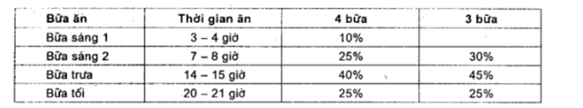

*Figure 2:12 Statistics of dividing the meals of the day of Vietnamese people* [[2]](https://drive.google.com/file/d/1WTg9GA-RXxcPPfJ1JojHX7fDRRZTa0GW/view?fbclid=IwAR0My0Ap6B-ZtjAJSDE5IYdCPgQ1eVPtqrp1oVNPHtRG03wNHaXeX7Bxu3g)

With the above knowledge, 4healthyNutrium wishes to be able to help advise Vietnamese users on how to maintain a healthy diet and exercise.

## 3. Existing Systems

### 3.1. Eat this much

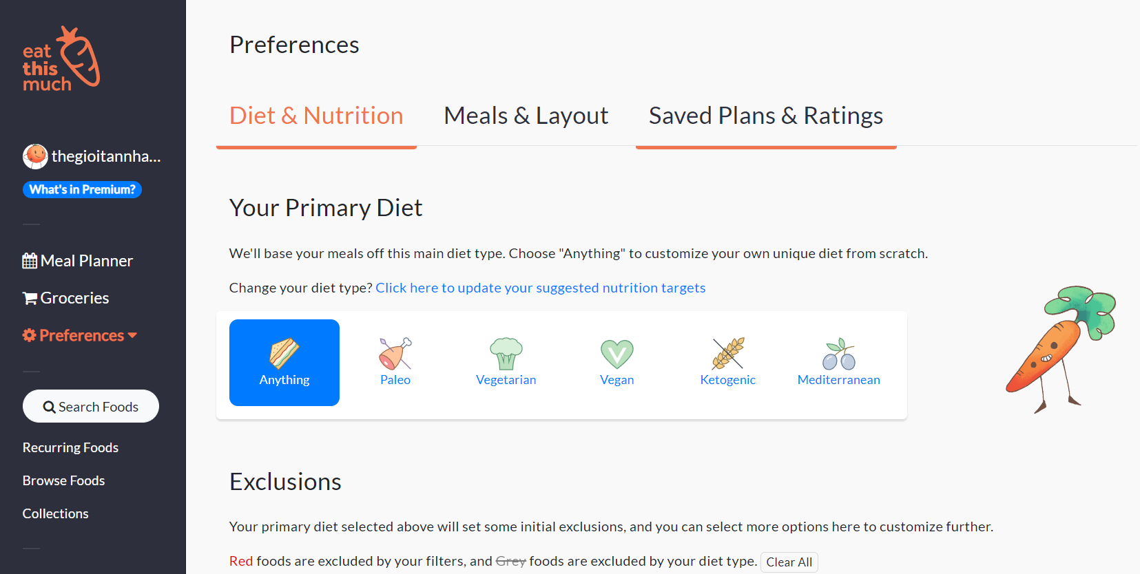

|  |  |
| --- | --- |
| **Advantages** | **Disadvantages** |
| * Easy to use, beginner-friendly. * Good classification about ingredient and food. * Automatically looking for diets. * Users can easily change their diets. | * Generated diets that are too high in fat. * Do not classify food and ingredients by season. |

Table 3.1. Advantages and disadvantages of Eatthismuch

### 3.2. Fatsecret

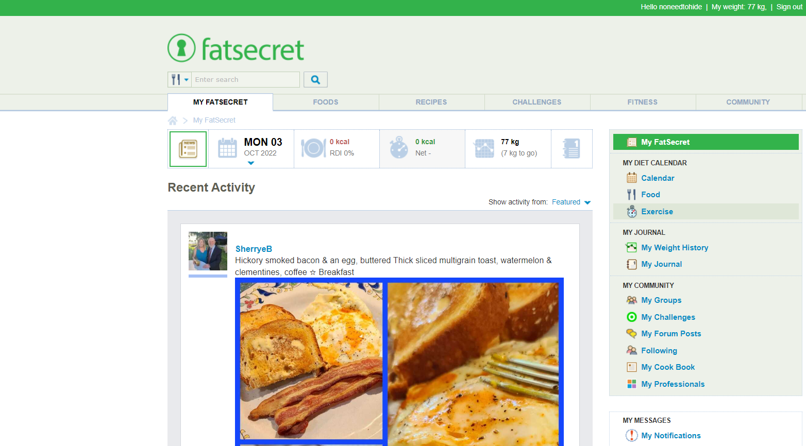

|  |  |
| --- | --- |
| **Advantages** | **Disadvantages** |
| * Easy to use. * Good calorie calculator. * Rich and varied nutritional information. * Having a social networking function that helps users easily connect with others. | * Significantly underestimates sodium and protein levels. * Do not classify food and ingredients by season. * Does not automatically generate dishes according to the calories entered. |

Table 3.2. Advantages and disadvantages of fatsecret

### 3.3. Myfitnesspal

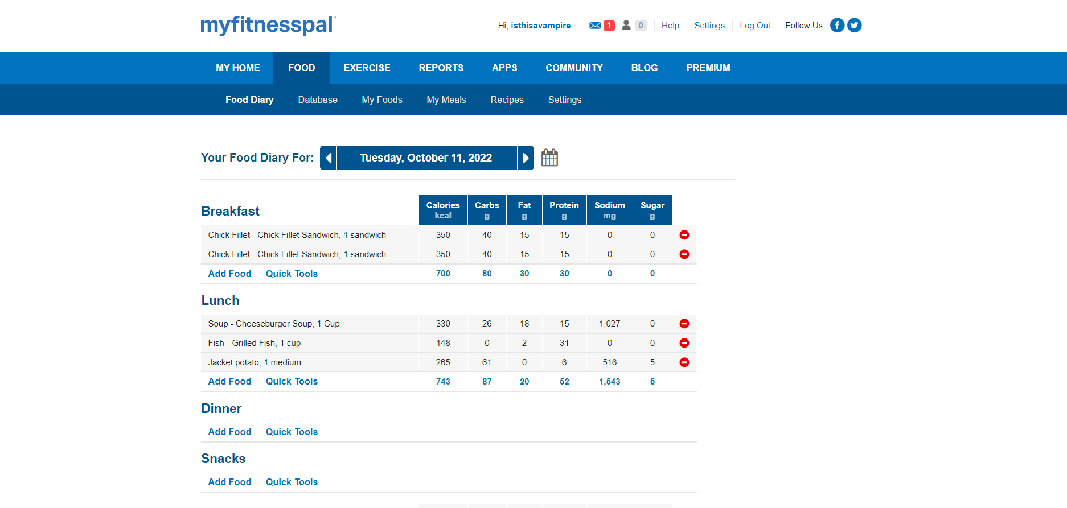

|  |  |
| --- | --- |
| **Advantages** | **Disadvantages** |
| * Users can track their water intake and macronutrients. * Extensive nutrient databases. * Recommended by dietitians. | * Underestimate micronutrients like calcium, iron, and vitamin C. * Quite complex to use. * Do not classify food and ingredients by season. |

Table 3.3. Advantages and disadvantages of myfitnesspaypal

## 4. Business Opportunity

Through the survey, we found that most of the survey participants wanted a website that could help them advise them to adjust their diet and exercise properly:

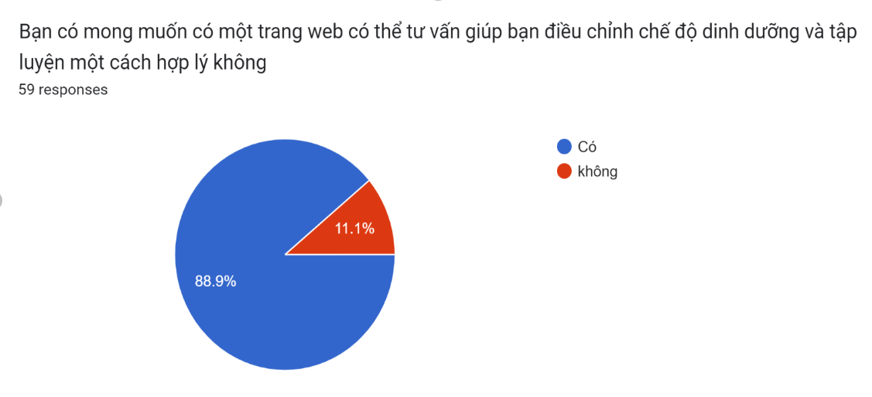

*Figure 4:1. Statistics of survey participants wanted a nutritional diet advice website*

Besides, the surveyed people also have the desire to be consulted on a diet suitable for each age, each season of the year:

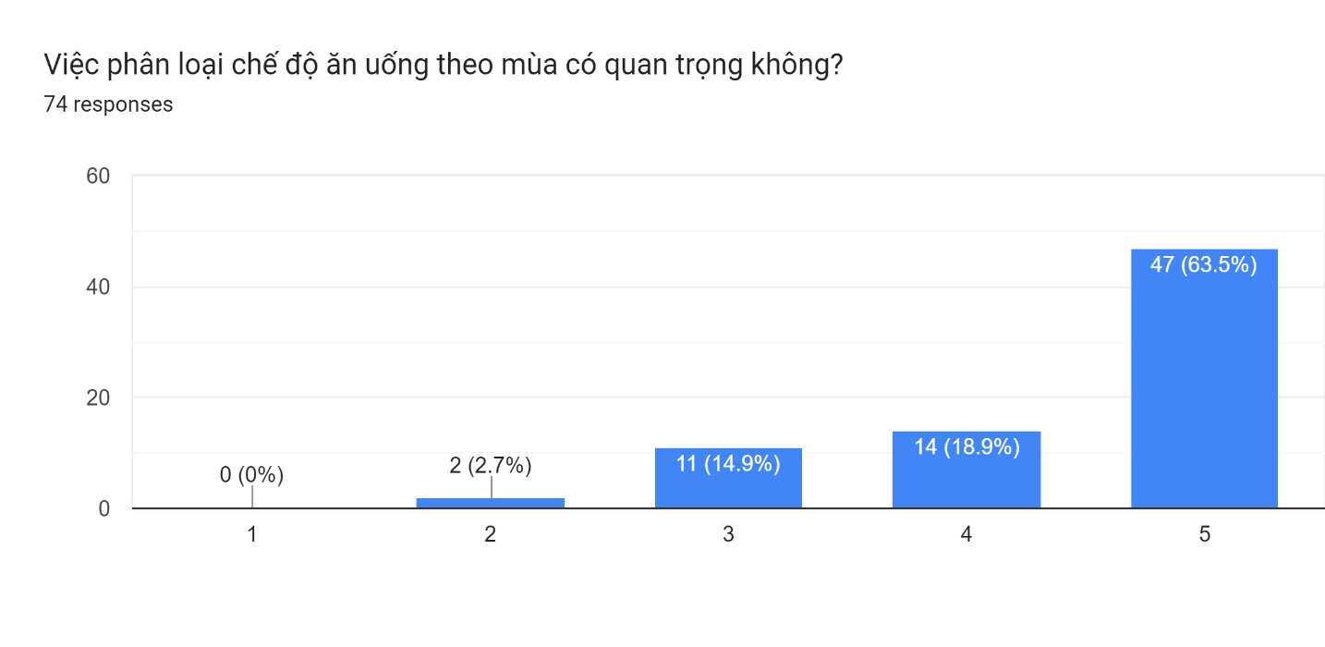

*Figure 4:2 Statistics about the importance of categorizing nutrition from seasonal food*

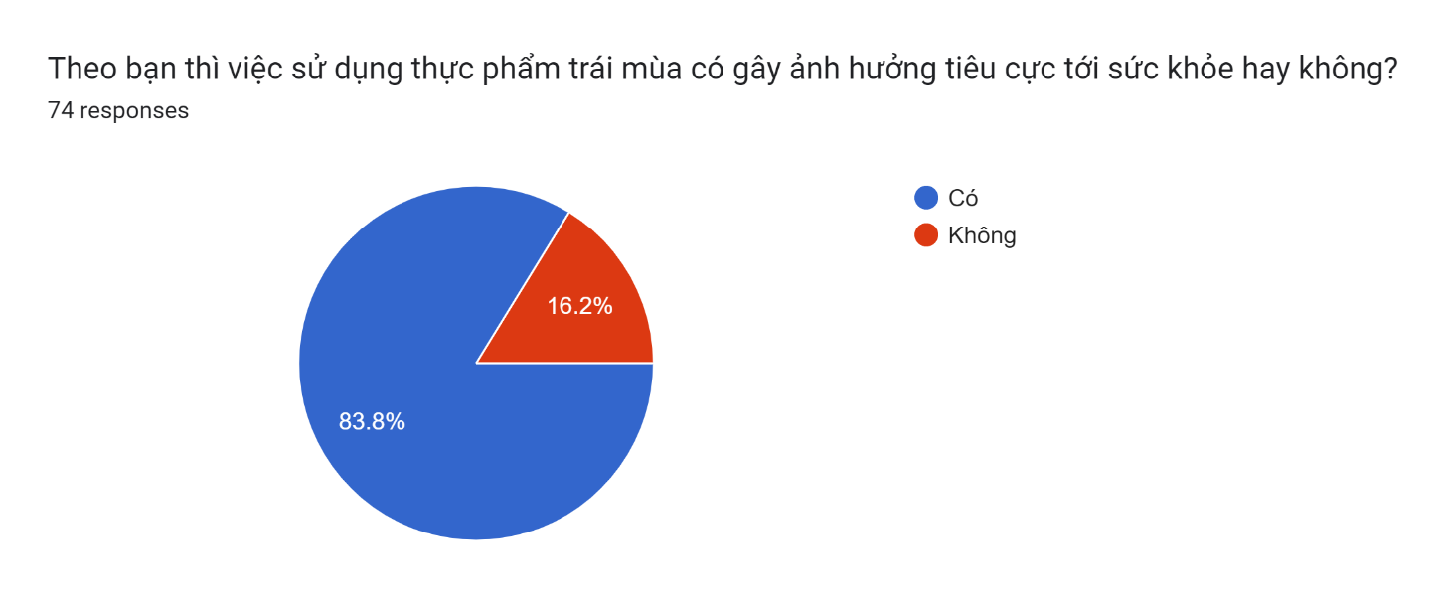

*Figure 4:3. Statistics about the flip side of out-of-season food*

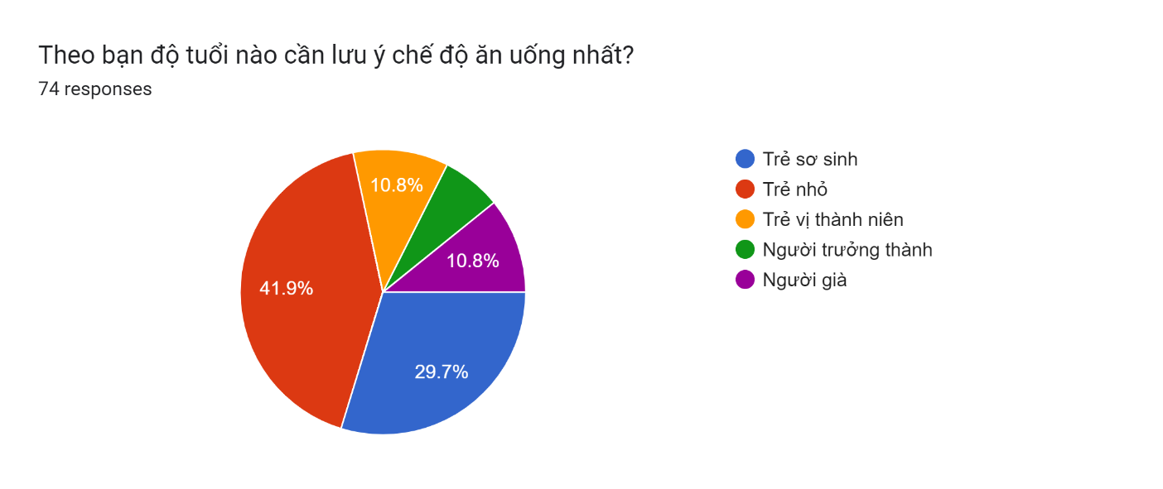

*Figure 4:4. Statistics about the importance of categorizing nutrition by age*

Through the information gathered from the survey, we have realized that it is very important to classify the diet by age and by season.

However, most of the energy-required dietary advice websites that exist today do not categorize these factors. Besides, the suggested dishes are all Western dishes and have a ratio of energy-producing substances that are not suitable for Eastern people in general and Vietnamese people in particular.

Therefore, with the target of healthy Vietnamese people who want to maintain and improve their health, 4HealthyNutrium will be a good choice for you.

## 5. Software Product Vision

For those who have health care needs through adjusting their nutrition, 4HealthyNutrium is a website that helps them calculate a reasonable portion size just by entering the number of calories they want to eat. Moreover, users can receive smart menus by entering weight, height, exercise intensity, ... From there, the system will help users calculate and offer a suitable diet. Besides, users can also get advice on their training regimen.

## 6. Project Scope & Limitations

### 6.1 Major Features

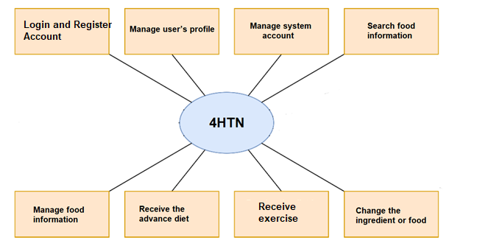

Figure 6.1. 4HTN’s major features

|  |  |
| --- | --- |
| **ID** | **Feature & Description** |
| FE-01 | Login and register account: Users must have an account to access other features in the system. |
| FE-02 | Manage profile: Users can manage their personal information. |
| FE-03 | Manage system account: Admin can manage accounts in the system to activate or deactivate a user. |
| FE-04 | Search food’s information: Users can search for nutrient value of food to get more information about diet. |
| FE-05 | Manage food’s information: Nutrition experts can edit food information, change the nutrient value of food and edit the food recipes. |
| FE-06 | Receive diet: Users will fill in some necessary information about their exercise, their height and weight, their job, their lifestyle and eating habit… to receive diet suggestion with timeline. |
| FE-07 | Change the ingredient or food: Users can change dishes or recipes in suggesting diet that they don’t want to use. The system will offer alternative dishes or ingredients that have the same nutritional value as those dishes. |
| FE-08 | Receive exercise: Users can receive their regular exercise. |

Table 6.1. List of major features.

### 6.2. Limitation & Exclusion

|  |  |
| --- | --- |
| **ID** | **Feature & Description** |
| LI-01 | Users cannot see other people's profiles. |
| LI-02 | Users cannot receive push notifications when not using the web. |
| LI-03 | The web doesn’t supports the Vietnamese language. |
| LI-04 | The web is not absolutely accurate, for reference only. |

Table 6.2:1. Limitations

|  |  |
| --- | --- |
| **ID** | **Feature & Description** |
| EX-01 | The web does not support uncommon dishes and ingredients. |
| EX-02 | The web does not support live streaming. |
| EX-03 | The web does not support dish and recipe leaderboards. |
| EX-04 | The web is not a social network or forum. |

Table 6.2:2. Exclusions